**Create an table ‘SAILORS’ with following fields**

|  |  |
| --- | --- |
| **Name** | **Type** |
| SID | NUMBER |
| SNAME | VARCHAR2(20) |
| JORATING | NUMBER |
| AGE | NUMBER |

SQL> create table sailors(sid number primary key,sname varchar2(30),rating number,age number);

Table created.

SQL> insert into sailors values(&sid,'&sname',&rating,&age);

Enter value for sid: 22

Enter value for sname: Dustin

Enter value for rating: 7

Enter value for age: 45

old 1: insert into sailors values(&sid,'&sname',&rating,&age)

new 1: insert into sailors values(22,'Dustin',7,45)

1 row created.

SQL> /

Enter value for sid: 29

Enter value for sname: Brutas

Enter value for rating: 1

Enter value for age: 33

old 1: insert into sailors values(&sid,'&sname',&rating,&age)

new 1: insert into sailors values(29,'Brutas',1,33)

1 row created.

SQL> /

Enter value for sid: 31

Enter value for sname: Lubber

Enter value for rating: 8

Enter value for age: 55

old 1: insert into sailors values(&sid,'&sname',&rating,&age)

new 1: insert into sailors values(31,'Lubber',8,55)

1 row created.

SQL> /

Enter value for sid: 32

Enter value for sname: Andy

Enter value for rating: 8

Enter value for age: 25

old 1: insert into sailors values(&sid,'&sname',&rating,&age)

new 1: insert into sailors values(32,'Andy',8,25)

1 row created.

SQL> /

Enter value for sid: 64

Enter value for sname: Horatio

Enter value for rating: 7

Enter value for age: 35

old 1: insert into sailors values(&sid,'&sname',&rating,&age)

new 1: insert into sailors values(64,'Horatio',7,35)

1 row created.

SQL> /

Enter value for sid: 58

Enter value for sname: Rusty

Enter value for rating: 10

Enter value for age: 35

old 1: insert into sailors values(&sid,'&sname',&rating,&age)

new 1: insert into sailors values(58,'Rusty',10,35)

1 row created.

SQL> /

Enter value for sid: 71

Enter value for sname: Zobra

Enter value for rating: 10

Enter value for age: 16

old 1: insert into sailors values(&sid,'&sname',&rating,&age)

new 1: insert into sailors values(71,'Zobra',10,16)

1 row created.

SQL> /

Enter value for sid: 74

Enter value for sname: Horatio

Enter value for rating: 9

Enter value for age: 35

old 1: insert into sailors values(&sid,'&sname',&rating,&age)

new 1: insert into sailors values(74,'Horatio',9,35)

1 row created.

SQL> /

Enter value for sid: 85

Enter value for sname: Art

Enter value for rating: 3

Enter value for age: 26

old 1: insert into sailors values(&sid,'&sname',&rating,&age)

new 1: insert into sailors values(85,'Art',3,26)

1 row created.

SQL> /

Enter value for sid: 95

Enter value for sname: Bob

Enter value for rating: 3

Enter value for age: 64

old 1: insert into sailors values(&sid,'&sname',&rating,&age)

new 1: insert into sailors values(95,'Bob',3,64)

1 row created.

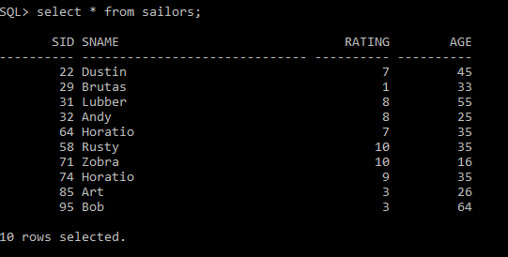

**Create an table ‘BOATS’ with following fields**

|  |  |
| --- | --- |
| **Name** | **Type** |
| BID | NUMBER |
| BNAME | VARCHAR2(20) |
| COLOR | VARCHAR2(20) |

SQL> create table boats(bid number primary key,bname varchar2(30),color varchar2(20));

Table created.

SQL> insert into boats values(&bid,'&bname','&color');

Enter value for bid: 101

Enter value for bname: Interlake

Enter value for color: Blue

old 1: insert into boats values(&bid,'&bname','&color')

new 1: insert into boats values(101,'Interlake','Blue')

1 row created.

SQL> /

Enter value for bid: 102

Enter value for bname: Interlake

Enter value for color: Red

old 1: insert into boats values(&bid,'&bname','&color')

new 1: insert into boats values(102,'Interlake','Red')

1 row created.

SQL> /

Enter value for bid: 103

Enter value for bname: Clipper

Enter value for color: Green

old 1: insert into boats values(&bid,'&bname','&color')

new 1: insert into boats values(103,'Clipper','Green')

1 row created.

SQL> /

Enter value for bid: 104

Enter value for bname: Marine

Enter value for color: Red

old 1: insert into boats values(&bid,'&bname','&color')

new 1: insert into boats values(104,'Marine','Red')

1 row created.

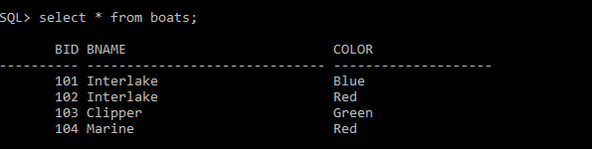

**Create an table ‘RESOURCES’ with following fields**

|  |  |
| --- | --- |
| **Name** | **Type** |
| SID | NUMBER |
| BID | NUMBER |
| DATE | DATE |

SQL> create table reserves(sid int references sailors(sid),bid int references boats(bid),day date);

Table created.

SQL> insert into reserves values(&sid,&bid,'&day');

Enter value for sid: 22

Enter value for bid: 101

Enter value for day: 10-OCT-1998

old 1: insert into reserves values(&sid,&bid,'&day')

new 1: insert into reserves values(22,101,'10-OCT-1998')

1 row created.

SQL> /

Enter value for sid: 22

Enter value for bid: 102

Enter value for day: 10-OCT-1998

old 1: insert into reserves values(&sid,&bid,'&day')

new 1: insert into reserves values(22,102,'10-OCT-1998')

1 row created.

SQL> insert into reserves values(&sid,&bid,'&day');

Enter value for sid: 22

Enter value for bid: 103

Enter value for day: 10-AUG-1998

old 1: insert into reserves values(&sid,&bid,'&day')

new 1: insert into reserves values(22,103,'10-AUG-1998')

1 row created.

SQL> /

Enter value for sid: 22

Enter value for bid: 104

Enter value for day: 10-JUL-1998

old 1: insert into reserves values(&sid,&bid,'&day')

new 1: insert into reserves values(22,104,'10-JUL-1998')

1 row created.

SQL> /

Enter value for sid: 31

Enter value for bid: 102

Enter value for day: 11-OCT-1998

old 1: insert into reserves values(&sid,&bid,'&day')

new 1: insert into reserves values(31,102,'11-OCT-1998')

1 row created.

SQL> /

Enter value for sid: 31

Enter value for bid: 103

Enter value for day: 11-JUN-1998

old 1: insert into reserves values(&sid,&bid,'&day')

new 1: insert into reserves values(31,103,'11-JUN-1998')

1 row created.

SQL> /

Enter value for sid: 31

Enter value for bid: 104

Enter value for day: 11-DEC-1998

old 1: insert into reserves values(&sid,&bid,'&day')

new 1: insert into reserves values(31,104,'11-DEC-1998')

1 row created.

SQL> /

Enter value for sid: 64

Enter value for bid: 101

Enter value for day: 9-MAY-1998

old 1: insert into reserves values(&sid,&bid,'&day')

new 1: insert into reserves values(64,101,'9-MAY-1998')

1 row created.

SQL> /

Enter value for sid: 64

Enter value for bid: 102

Enter value for day: 9-AUG-1998

old 1: insert into reserves values(&sid,&bid,'&day')

new 1: insert into reserves values(64,102,'9-AUG-1998')

1 row created.

SQL> /

Enter value for sid: 74

Enter value for bid: 103

Enter value for day: 9-AUG-1998

old 1: insert into reserves values(&sid,&bid,'&day')

new 1: insert into reserves values(74,103,'9-AUG-1998')

1 row created.

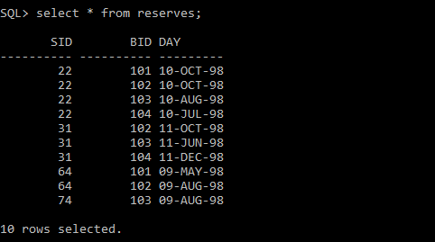

1. Find the names and ages of all sailors

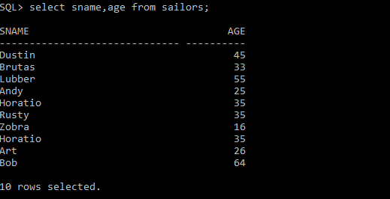

1. Find all information of sailors who have reserved boat number 101.

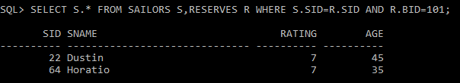

1. Find all sailors with rating above 7

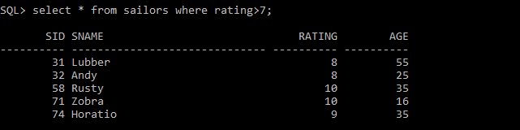

1. Find the names of sailors who have reserved boat no 103

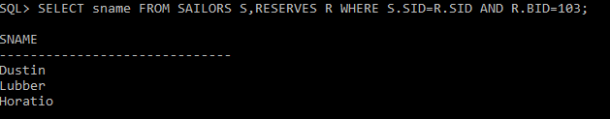

1. Find the names of sailors who have reserved a red boat, and list in the order of age.

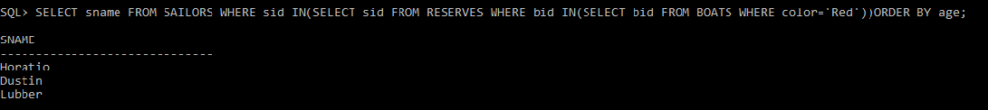

1. Find the names of sailors who have reserved either a red or green boat

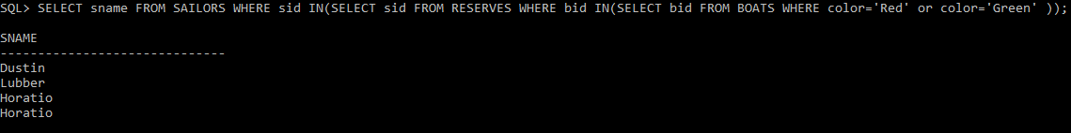

1. Find the colors of boats reserved by “Lubber”.

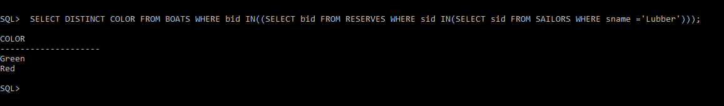

1. Find the names of sailors who have reserved both red and green boats

